Find below steps to update passport number on Vaccination Certificate.

Step 1 : Register or Sign In for Vaccination to <https://selfregistration.cowin.gov.in/>

Step 2 : Put your register mobile number An OTP will be sent to your mobile number for verification.

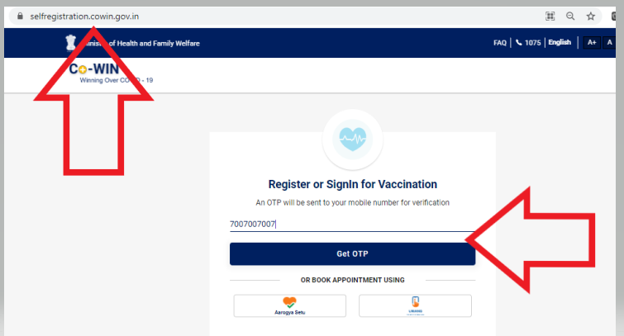

After OTP

